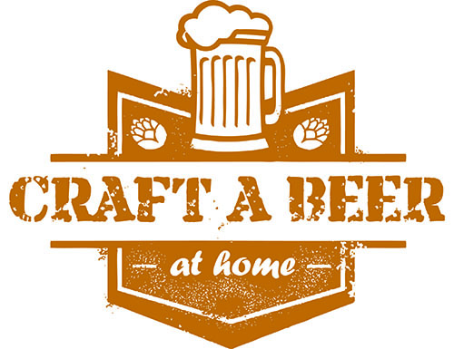

Saturday, July 27, 2019 5:30-8:30pm

Indian Valley Beer Fest at the Library
100 E. Church Rd. Telford, PA
215-723-9109

HOME BREWER COMPETITION ENTRY FORM

BREWER CONTACT INFORMATION

Name:
Street Address:
Street Address 2:
City:
State / Zip Code:

Phone 1: -
Phone 2: -

Email Address:

Member of a Home Brewer’s Club?

How did you hear about the Home Brewer’s Competition?

HOME BREW INFORMATION

Beer Name:

Beer Style:

Do a Save As -- which includes your last name -- onto your computer.
Email your completed entry form to jpfahler@comcast.net.
Text or call with questions: 610-417-1723

